Assignment 2

Enhancing Development Through Automation
Automation is a crucial aspect in the contemporary software development since it minimizes manual repetitive methods and also ensures the consistency of the system in its behaviour during testing and operation. Helix Clinical Data Processor automation has been applied to multiple aspects of the application to enhance reliability, enhance efficiency and facilitate continuous maintenance. The automated logging of errors is also an important automation aspect that has been applied to the system, as also is the adoption of background worker threads to run tasks without holding back the graphical user interface. These automated behaviours also make the development process easier and give predictable and structured outputs that help in debugging and verification processes.
Automated Error Logging with Timestamped and GUIDs
The Helix system logs all validation problems automatically by providing an error-logging capability. This operation produces a timestamp, a special identifier called GUID, a structured log record, and it will be added to the error report without any interference of the developer. This automation helps during debugging as it makes sure that all invalid CSV files leave a traceable and consistent log.
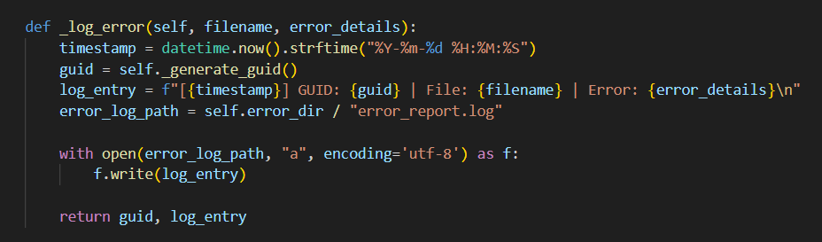
Figure 1Error Logging Function
This role is automated such that the date, GUID, and the format of the message are generated programmatically and directly written to the log file. Application developers do not have to manually monitor errors, and the process of debugging is more accurate and predictable.
The automated test of errors logging proved that the function works correctly and creates a timestamped entry, a unique GUID and writes the formatted message to the error-report.log.
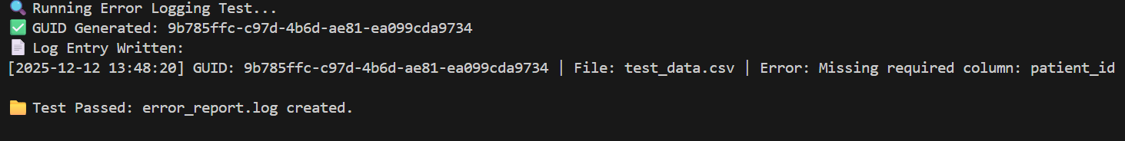
Figure 2 Error Logging function Test Result
The output of this test was the GUID and the full log entry and the fact that the log file was created successfully confirmed that the automated test process is as it should be. This goes to show that the logging mechanism is stable and creates stable diagnostic data as it goes through the development cycle.
Automated Background Processing Using Multi-Threading
Threading tests are automated and done to ensure that background tasks are independent and do not block the main application. Background threads are involved with connecting with the server, refreshing files, and validation of selected data in the Helix system. In order to test this behaviour, an independent threading test was developed. The test puts three independent threads onto the test, which emulate each of the background activities and time their completion. This also makes sure that the application is capable of handling simultaneous tasks with a high level of reliability when using it on the actual operation.
The test script uses three distinct worker threads to model the core asynchronous tasks of Helix. Each thread executes a dummy function which mimics the original process and adds a result message on completion. It was shown in figure 3.

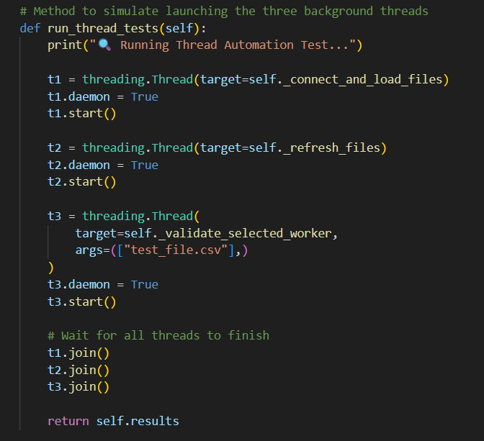
Figure 3 Thread Execution Test
This part of the test confirms that every task is performed in a different background thread. The start () is an asynchronous method and the method join is a method that ensures that before the test is completed all the threads have been finished. This proves that multithreading works as expected.
This test was able to run all three background threads and each of the dummy functions indicated completion. This proves that thread-creation, execution and termination process is successfully carried out.
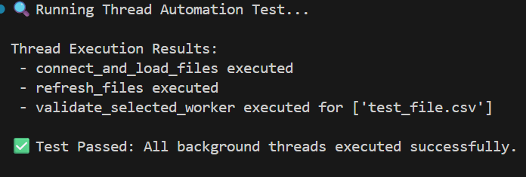
All three tasks were performed successfully and error-free, which once again proves that the threading structure of the system is effective and can be used to conduct background work within the Helix application.
Using an External API to Support Development Tasks
External APIs are useful in the present-day software development as they enable applications to delegate specialised functionality such as creating uniquely identifiable numbers, accessing data or verifying its correctness to trusted third parties. By adding an API, it is possible to not only test, but also be able to assure consistency and lessen the number of logic lines that the development team will be required to support in-house. In the Helix Clinical Data Processor, the creation of universally unique identifiers (UUIDs) to the entries in the error-log is created using an external API. This makes sure that every invalid file found on testing is labelled with a unique externally generated identifier, enhancing traceability and for structured debugging.

API Integration for GUID Generation
To increase the accuracy of the error-logging mechanism of the system, Helix obtains the UUIDs values of the external service uuidtools.com. These identifiers are sent back in the form of a JSON and then attached to every log entry that is created in a validation process. When the API is not accessible, the system will automatically revert to the python inbuilt uuid module to maintain normal operations.
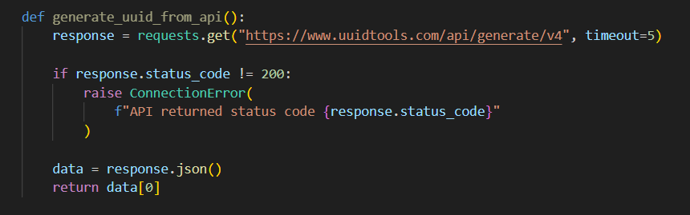
Figure 4API UUID Request
This approach calls the UUIDTools API using a GET request and retrieves a newly generated UUID using the JSON response. The system attempts to accommodate this externally developed value in writing error logs and each problem is distinctly and consistently identified. Fallback logic is included, which ensures the stability of the system and offline working.
Figure 6 shows, If the API request fails, the script generates a fallback UUID and logs the error.
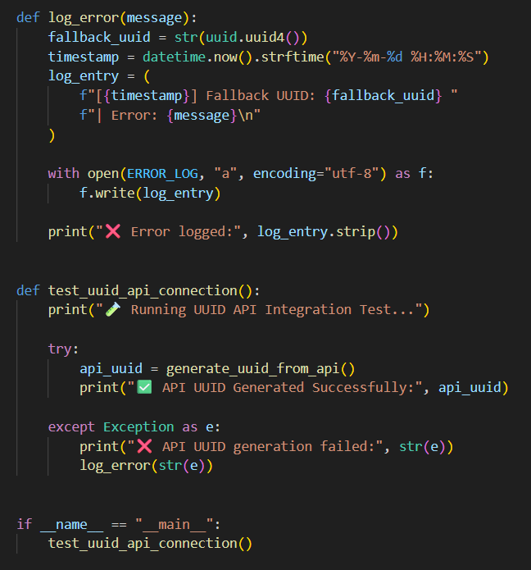
Figure 5 Error Logging Handler
This function records failed API attempts by generating a fallback UUID, adding a timestamp, and writing the information to the error log file.
In figure 7, it’s shown the primary test functionality joins all the components together and indicates the workability of the API.
Figure 6 Test Execution Routine
In the event that the external API is functional, it reads and shows the generated UUID. In case the API request could not be made due to any reason, the script will automatically capture the error and create a fallback UUID so that the problem is well documented.

The automated test was implemented with the help of the Python interpreter, and the system was able to reach the external UUIDTools API. The API provided an efficient UUID value, which verified that the connection was running and in operation during the period of testing. The output received was shown in figure 8.
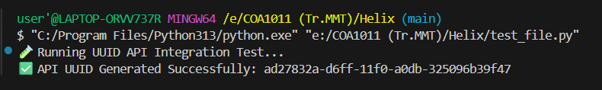
Figure 7 Test Result
The fact that the UUID was successfully retrieved proves that the API endpoint is available, the JSON response is correct, and the test script integration logic is functioning properly. The fallback mechanism of error-logging was not contained because of no exceptions, which means that the system could rely on the external service in the regular conditions.

